Project Timeline

Project Title: Simon Says
Engine: Godot 4.4
Estimated Duration: ~6 weeks

Goal
Develop a polished Simon Says-style memory game with progression, visual/audio feedback, and speed scaling.

Gantt-Style Schedule Overview
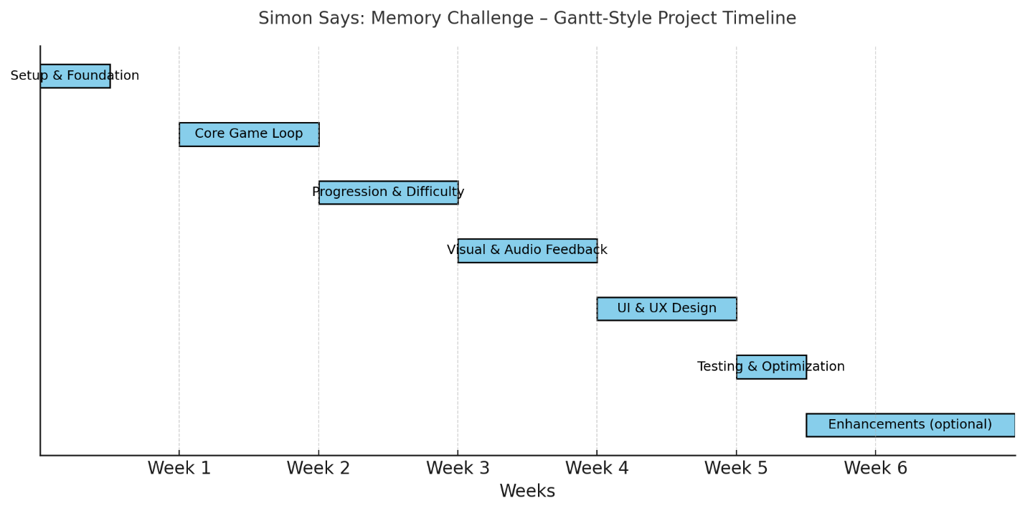

Phase 1 – Setup & Foundation (2-3 days, Week 1)

Goal
Establish the project structure and base scenes.

Tasks
- Create a new Godot project and folder structure (/scenes, /scripts, /assets).
- Create placeholder scenes:
  - main.tscn
  - start_screen.tscn
  - hud.tscn
  - button.tscn
- Define main game loop logic
  - (Sequence → Playback → Input → Check → Next).
  - Set up color palette and exported variables for button colors/signals.
- Set up Github repository.

Deliverable
Project with functioning placeholders and organized scene hierarchy.

Phase 2 – Core Game Loop (Week 2)

Goal
Implement Simon Says gameplay fundamentals.

Tasks
- Create 3 starting colored buttons (red, blue, yellow).
- Implement sequence generation and playback logic.
- Handle player input detection and comparison.
- Add basic round reset and fail condition.

Deliverable
Playable core mechanic with working success/failure feedback.

Phase 3 – Progression & Difficulty Systems (Week 3)

Goal
Add round progression, scaling, and button unlock logic.

Tasks
- Track round number and score.
- Extend sequence length per round.
- Add a new button every 10 rounds (up to 6 max).
- Adjust layout dynamically for additional buttons.

Deliverable
Dynamic gameplay with increasing challenge through longer sequences.

Phase 4 – Visual Feedback (Week 4)

Goal
Add visual cues for clarity and player interaction.

Tasks
- Button glow/flash animations for activation.
- Success/fail visual effects (e.g., color flashes, screen highlight).
- Subtle background or transition effects between rounds (STRETCH).

Deliverable
Visual feedback system for all gameplay interactions.

Phase 5 – UI & UX Design (Week 5)

Goal
Complete menus and presentation.

Tasks
- Main Menu, HUD, and Game Over Screen.
- Display round number, score, and difficulty indicators.
- Add Pause and Restart functionality.

Deliverable
Full user experience loop: menu → gameplay → end → replay.

Phase 6 – Testing & Optimization (Week 6, early)

Goal
Ensure stable, bug-free gameplay

Tasks
- Test sequence logic and player input.
- Fix animation glitches and edge cases.
- Optimize timers, loops, and signals.

Deliverable
Stable, polished, and playable final build.

